WILL CALL ORDER FORM
Email: jwetherbee@ideal-ap.net
Direct: 904-417-6403
www.ideal-ap.net

Date: |  | Master #
Dealer:
PO # (Required):
Contact Name/Email:
Contact Number:
Signature:

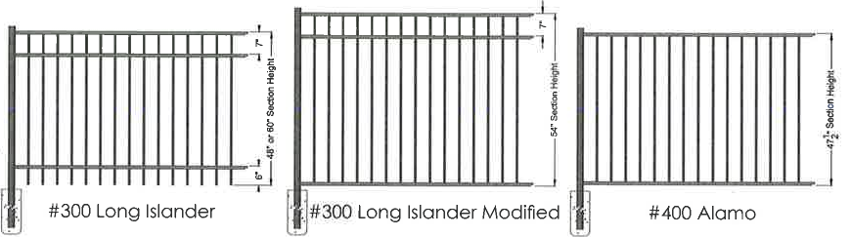
AVAILABLE | GRADE (PICKET SIZE) | HEIGHT(S) | WALK GATE WIDTHS | FENCE POST | GATE POST
#300 Long Islander (Rackable) | Residential (5/8”) | 48” & 60” | 48” & 60” | 2” sq. x .055 | 2” sq. x .093
#300 Long Islander Modified (Rackable) | Residential (5/8”) | 54” | 48” & 60” | 2” sq. x .055 | 2” sq. x .093
#400 Alamo | Residential (5/8”) | 48” | 48” & 60” | 2” sq. x .055 | 2” sq. x .093

Fence posts Residential 70” & 84”H | Guidelines
Gate posts 72” & 88”H | Black only / Select styles  Order quantity does not exceed 100 panels  Place order day before picking up  * Orders placed before 12 noon will be available between 7a & 2p the following business day  * Orders placed after 12 noon will be available for pick in two business days between 7a & 2p  **No pick-ups will be permitted after 2pm

Fill out order form here
STYLE  (**Available in Rackable) | RACKABLE  (Y/N) | 72” W  SECTION  QTY | LINE POST  QTY | END POST  QTY | CORNER POST  QTY | GATE POST  QTY | 48” W  WALK GATE QTY | 60” W  WALK GATE QTY
#300 Long Islander 48”H Residential **
#300 Long Islander 60”H Residential **
#300 Long Islander Modified 54”H Residential **
#400 Alamo 48”H Residential | N/A

HARDWARE | QTY |  | NOTES
Aluminum Self Closing Hinge (ea – 2 per)
Tru Close Hinge (pair – 1 set per)
Lokk Latch (DDLLAA)
Magna Latch Series 3 Tall (DDML3TPKA)
Gravity Latch (GLB)
Drop Rod (DDQB124)
 |  |  | iDeal Aluminum Products
Post Caps |  |  | 3200 Parker Drive
Gate Caps |  |  | St. Augustine, FL 32084
Screws |  |  | Main: 904-417-6400
 |  |  | Toll: 877-323-6496

